Student Name | G. Manasa
Student Registration Number | 241U1R3007 | Class &Section: CSE(DS)
Study Level: UG/PG | UG | Year &Term: I & II
Subject Name | Probability & statistics

Name of the Assessment | Reflective Journal -6
Date of Submission | 17-08-2025

Reflective Journal Template
Journal Entry Guidelines | Description
1. Experience (Class Content) | Briefly describe the topics or concepts discussed during the class.
2. Feelings (Emotional Reactions) | Share your emotional reactions and thoughts during the class.  How did you feel while learning this theory?  Did the class evoke specific emotions or questions?
3. Learning (Key Insights) | Reflect on what you learned from the class.  Highlight the key insights or fundamental concepts you gained from the class.
4. Application (Practical Use) | Describe how you plan to apply the theory you've learned in real-life situations or in your academic/career endeavours.  Explain the practical utility of this theory.

Sample Journal Entry

Date | 17-08-2025
Journal Entry Topic | Testing of Hypotheses Null –Hypothesis, Alternative Hypothesis, Type –I error and Type-II Error, Level of significance, Critical values.
1. Experience (Class Content) | In this module we learned about hypothesis it is a statement which is to be tested for its acceptance it is denoted by H. and next statistical hypothesis it is a certain statement about probability distribution of a random variable and next learned about simple statistical hypothesis it specifies the population completely and next we discussed about composite statistical hypothesis it do not specify the population completely eg: H$\sim N(μ,σ^{2})$ and next I learned about types of hypothesis there are two types of hypothesis  - Null hypothesis  - Alternative hypothesis  Null hypothesis is hypothesis which asserts that there is no significant it is denoted by Ho  A statistical hypothesis which is complementary to the null hypothesis is alternative hypothesis  And we discussed about level of significance it is denoted by α , critical region is a sample value falling is rejected and next we discussed about types of errors there are two types of errors type I error and type II error  Type I error is the error rejecting null hypothesis Ho when it is true.  Type II error is the error accepting the null hypothesis Ho when it is false.  And one tailed test and next we learned about right tailed and left tailed test and next two tailed test a test of statistical hypothesis where the alternative hypothesis is two tailed
2.Feelings (Emotional Reactions) | I felt confused at first because there were many terms like null hypothesis, alternative hypothesis, and types of errors. But as the class went on I started to understand better with the examples given. I felt interested when I saw how these concepts are used in real life, like in medicine and sports. Learning about Type I and Type II errors made me realize how small mistakes in testing can make a big difference. Overall I felt curious engaged and happy that I could connect the theory to practical examples.
3. Learning (Key Insights) | 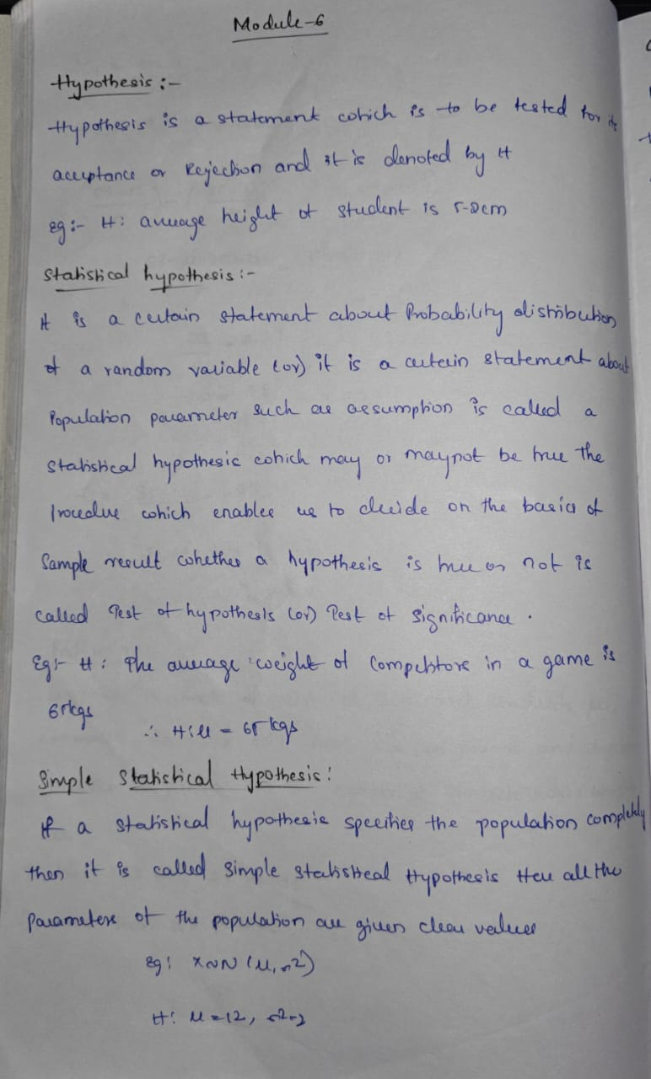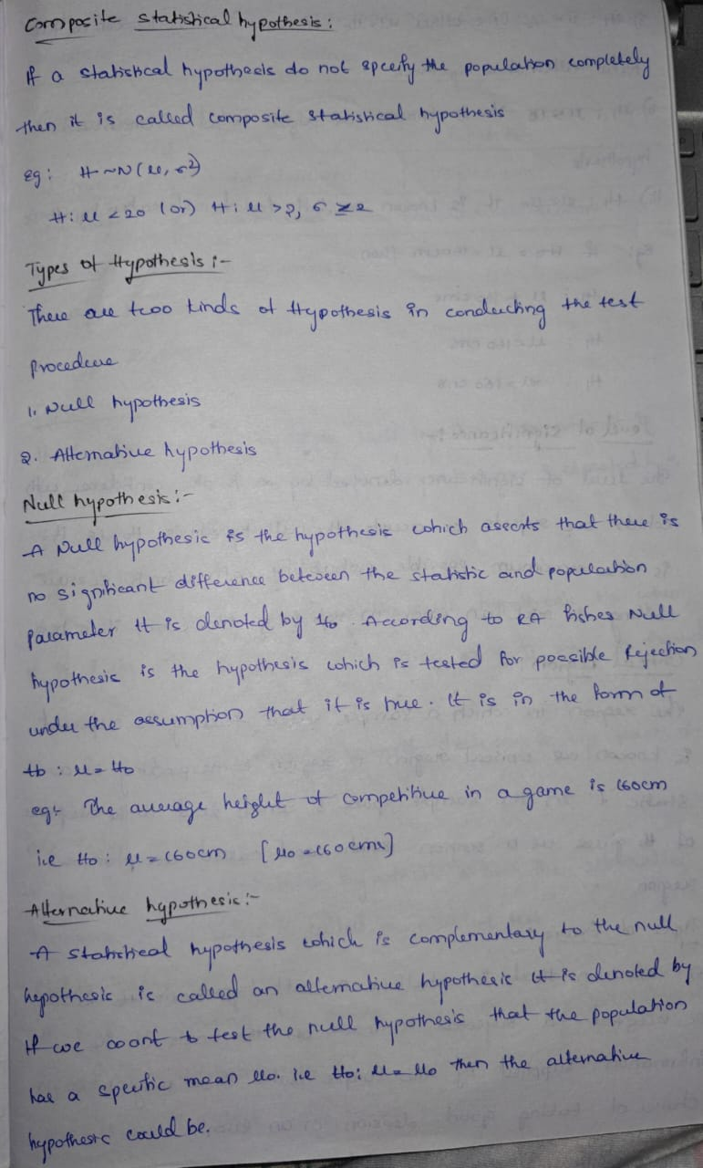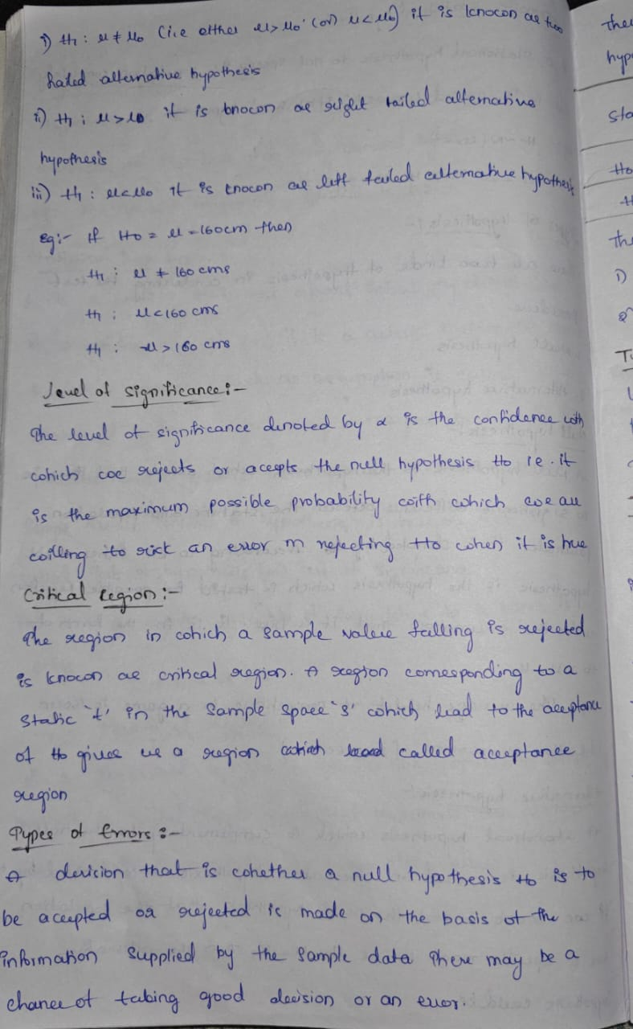  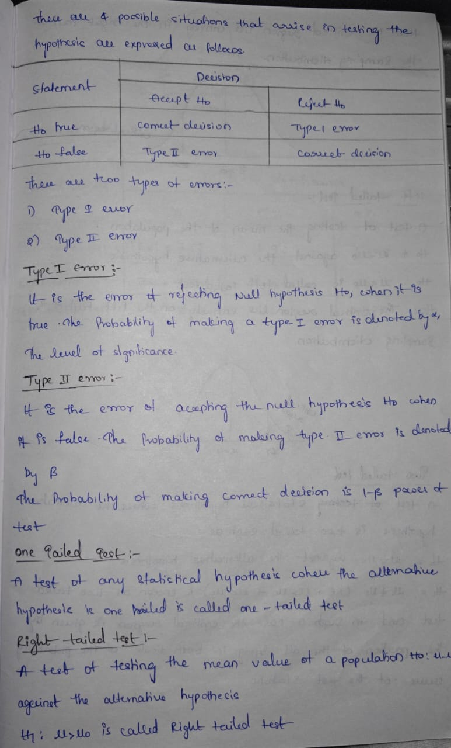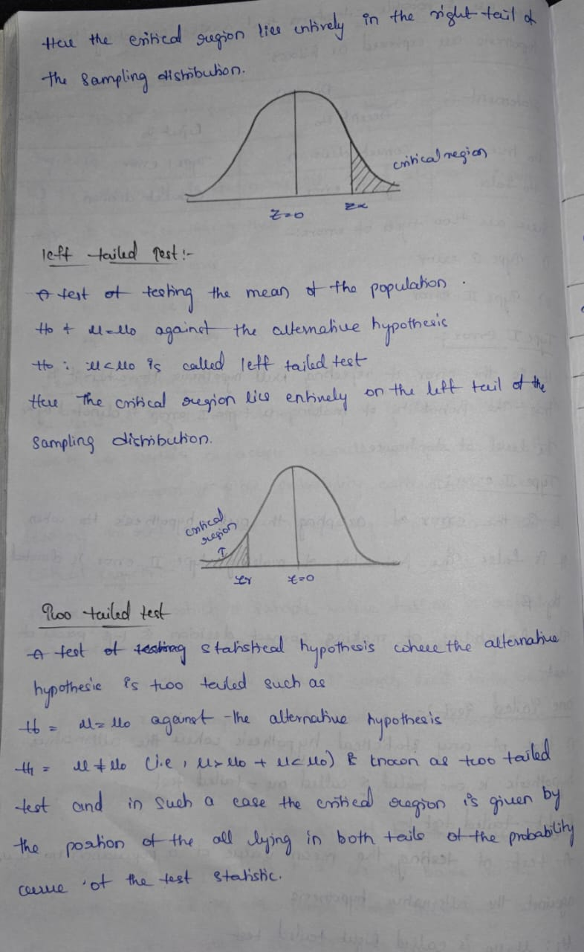  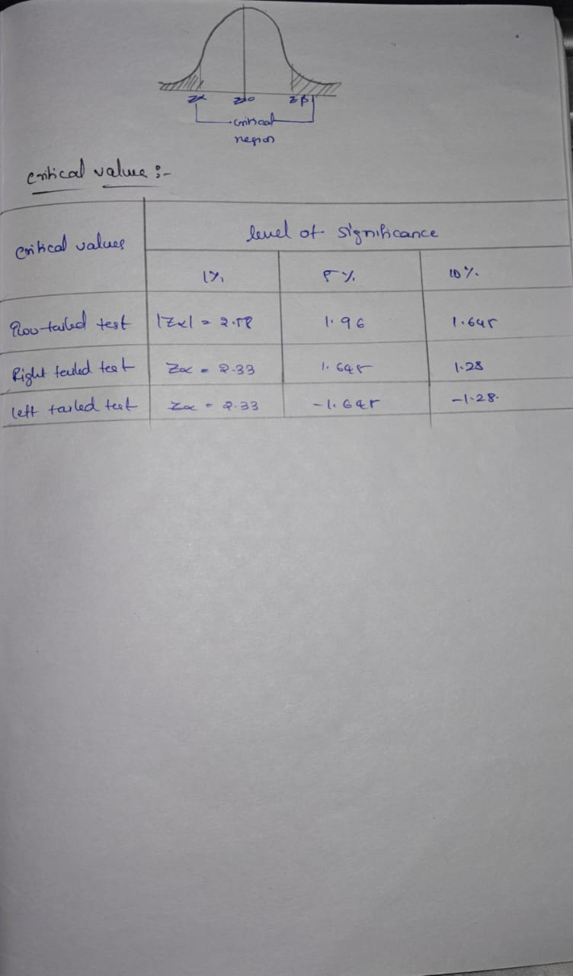
4. Application (Practical Use) | 1. Null Hypothesis (H₀): Assumes there is no difference or effect.  Applications:  - In medicine: Checking if a new drug has no better effect than the old one.  - In education: Testing if a new teaching method gives the same results as the traditional method.  - In manufacturing: Checking if the average diameter of produced bolts equals the specified value.  2. Alternative Hypothesis (H₁ or Ha)  Opposite of the null hypothesis; assumes there is a difference or effect.  Applications:  - In marketing: Seeing if a new advertisement increases sales.  - In agriculture: Testing if a new fertilizer increases crop yield.  - In quality control: Checking if the defect rate in a product is higher than acceptable.  3. Type I Error  Rejecting a true null hypothesis (false alarm).  Applications:  - In court trials: Declaring an innocent person guilty.  - In security: Alarm system rings when there’s no intruder.  - In medicine: Approving a drug that doesn’t actually work.  4. Type II Error  Not rejecting a false null hypothesis (missed detection).  Applications:  - In court trials: Letting a guilty person go free.  - In quality testing: Accepting a faulty batch as good.  - In medical diagnosis: Failing to detect a disease that is present.  5. Level of Significance (α)  The probability of making a Type I error; usually 0.05 or 5%.  Applications:  - In scientific research: Setting α = 0.05 means accepting a 5% risk of wrongly rejecting H₀.  - In clinical trials: Choosing a stricter α = 0.01 for life-saving drugs to reduce false approvals.  - In finance: Testing trading strategies with α = 0.10 for faster decisions.  6. Critical Value  The threshold value that determines whether to reject H₀.  Applications:  - In exams: Setting a pass mark (e.g., 40%) as the critical value for passing.  - In sports: Setting a minimum score to qualify for the next round.  - In research: Using z-table or t-table values to decide test results.
Conclusion | Hypothesis testing is a way to check if something is true using data. First, we assume nothing has changed null hypothesis. Then we also think about the opposite that something has changed alternative hypothesis. We compare our results to a limit critical value to decide which one to believe. Sometimes we can make mistakes Type I error is when we say something is true but it’s not, and Type II error is when we miss something that is actually true. The level of significance is how much chance we are okay with to be wrong. This is used in real life for testing new medicines, checking product quality, sports performance, and many more things.

